Funding Workbook for All California Tribes Outreach Packet

New Funding Resource for California Tribes

Thank you for your interest in helping to get the word out about the Funding Workbook for All California Tribes (Funding Workbook)! We hope these template materials will make it easy for you to take and share with your co-workers, family, and community. If you have any questions about this packet, please contact Cristina Echeverria at Cristina.Echeverria@arb.ca.gov.

Newsletter blurb and graphic: Includes sample image, brief paragraph about the Funding Workbook, and a call to action to download or request a free physical copy.
- This newsletter blurb is meant to be used by Tribes, organizations, groups, or agencies that would like to share the Funding Workbook with their network.
Direct email template: Concise overview of the Funding Workbook as well as a brief paragraph on what California Climate Investments is, with a call to action to download or request a free physical copy.
- This email template is intended to be sent to individuals or groups who might benefit from being informed of/using the Funding Workbook.
Social media blurbs and graphics: Provides social media text and graphics about the Funding Workbook that can easily be shared on Facebook or Twitter/X.

Newsletter blurb and graphic
Subject Line: New: Funding Workbook for All California Tribes
Blurb: California Climate Investments is excited to announce a new funding resource for California Tribes.
The Funding Workbook for All California Tribes (Funding Workbook) guides Tribal leaders and Tribal staff through assessing which California Climate Investments funding opportunities may be a good fit for your Tribe’s needs and priorities. The Funding Workbook is designed for everyone from previous grantees to Tribal leaders and staff who are exploring State climate programs for the first time. The Funding Workbook is meant to serve all Tribes, regardless of federal recognition, and includes Tribes who operate as nonprofits.

Visit the California Climate Investments website to learn more about the Funding Workbook, download a copy, request free copies, or make suggestions about the engagement and support you’d like to see from the California Climate Investments team.
bit.ly/FundingWorkbook
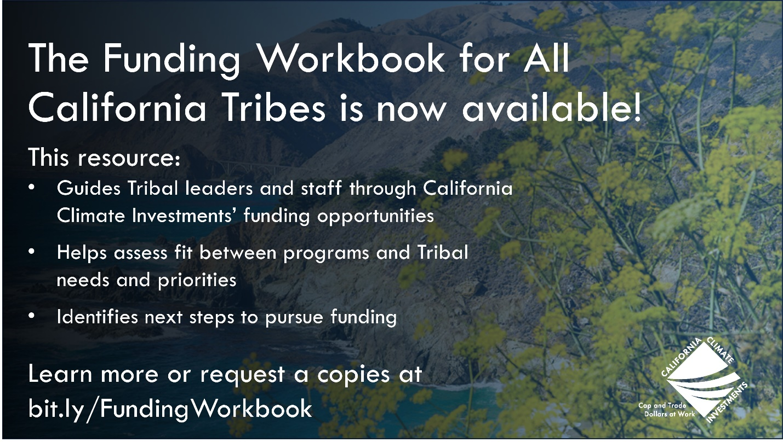

Direct email template
Hello [NAME],
California Climate Investments has just released the Funding Workbook for All California Tribes (Funding Workbook) which may be of interest to your or your network.
[PERSONAL COMMENT]

The Funding Workbook guides Tribal leaders and staff through assessing which California Climate Investments funding opportunities may be a good fit for Tribal needs and priorities. The Funding Workbook brings together program information that may be of particular interest to Tribes and is meant to serve all Tribes, regardless of federal recognition or previous experience with State climate programs.

California Climate Investments is a portfolio of programs that take auction proceeds from Cap-and-Trade and uses them to fund projects that reduce greenhouse gas emissions, strengthen the economy, and improve public health and the environment — particularly in disadvantaged and low-income communities.

Visit bit.ly/FundingWorkbook to learn more, download a copy, request free copies, or make suggestions about the engagement and support you’d like to see from the California Climate Investments team. If you have any questions, please contact info@caclimateinvestments.ca.gov.

We hope you and others in your network will find this resource helpful!
Thank you,
[Sign]

Social Media blurbs and graphics

Twitter/X blurbs
- Blurb 1
#CAClimateInvestments just launched a new resource to guide California Tribal leaders & staff through available funding opportunities for climate projects. Learn more ➡️ bit.ly/FundingWorkbook
- Blurb 2
📣 The Funding Workbook for All California Tribes is live! Explore funding opportunities for climate projects led by Tribes with #CAClimateInvestments➡️ bit.ly/FundingWorkbook
- Blurb 3
Is your California Tribe interested in exploring climate funding? Check out #CAClimateInvestments' new Funding Workbook for All California Tribes to see if any programs match with your Tribe’s needs & priorities. ➡️ bit.ly/FundingWorkbook

Facebook blurbs
- Blurb 1
@CAClimateInvest just launched the Funding Workbook for All California Tribes. This resource may be of particular interest to you if your Tribe:
  - Is new to State climate programs
  - Does not currently have federal recognition or operates through a nonprofit
  - Has limited capacity and wants a streamlined way to narrow down programs
  - Wants to explore programs based on the Tribal cultural preservation priorities they may be able to support
Visit the California Climate Investments website to download a copy, request free copies, or make suggestions about the engagement and support you’d like to see. bit.ly/FundingWorkbook
- Blurb 2
@CAClimateInvest is pleased to announce the Funding Workbook for all California Tribes. California Climate Investments funds a wide range of climate- projects including transportation and mobility, agriculture and food waste prevention, fire management, and more.
The Funding Workbook:
Guides Tribal leaders and Tribal staff through funding opportunities
Provides next steps, questions to consider asking, and program contacts
Offers an overview of how to get involved in shaping programs to better align with your Tribe’s needs
Visit the California Climate Investments website to download a copy, request free copies, or make suggestions about the engagement and support you’d like to see. bit.ly/FundingWorkbook

Social media graphics
Option 1
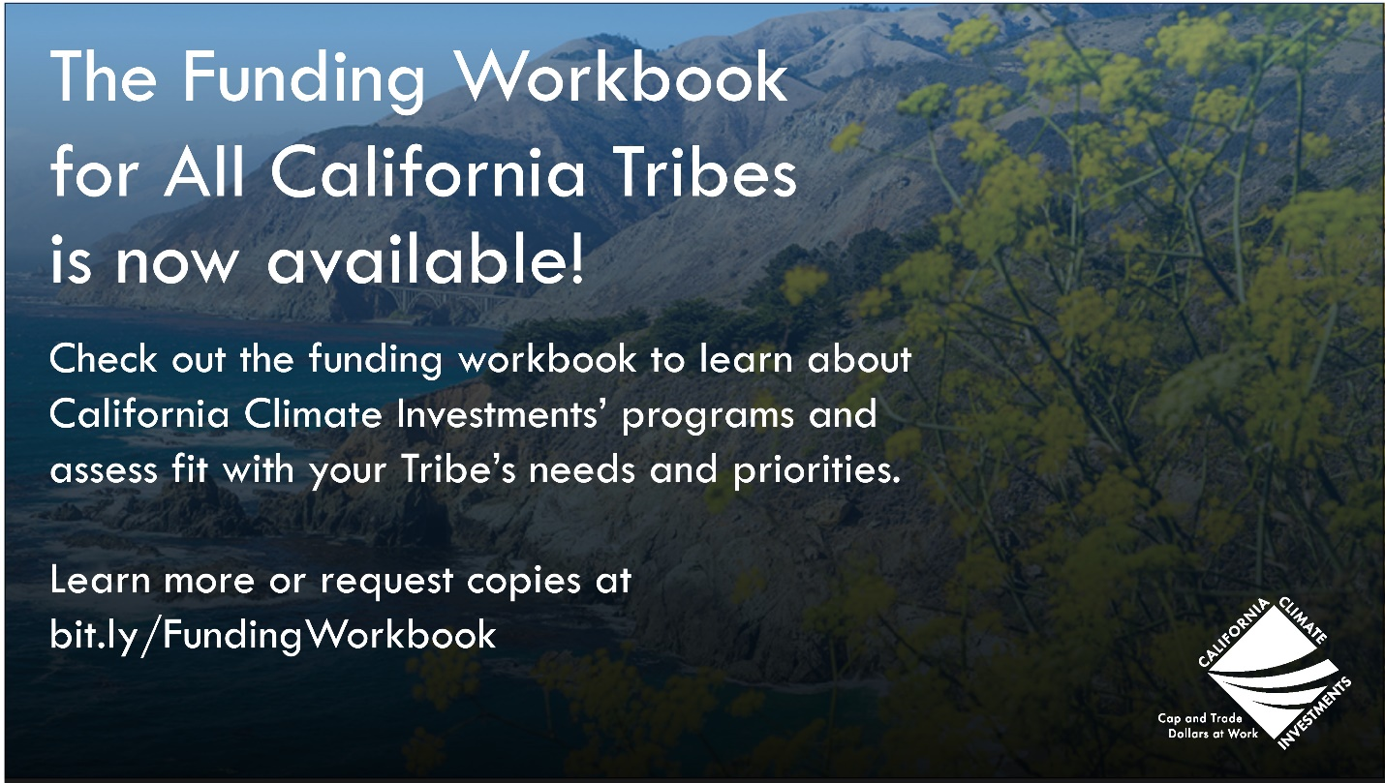
Option 2

Option 3
A collection of 6 images:
